Software Requirements Specification
for
< Techcombank Online Banking App >
Version 4.0 approved
Prepared by <Thanh Ba>
<Personal>
<August 2025>
Table of Contents
Table of Contents ii
Revision History ii
1. Introduction 1
1.1 Purpose 1
1.2 Document Conventions 1
1.3 Intended Audience and Reading Suggestions 1
1.4 Project Scope 1
1.5 References 1
2. Overall Description 2
2.1 Product Perspective 2
2.2 Product Features 2
2.3 User Classes and Characteristics 2
2.4 Operating Environment 2
2.5 Design and Implementation Constraints 2
2.6 User Documentation 2
2.7 Assumptions and Dependencies 3
3. System Features 3
3.1 System Feature 1 3
3.2 System Feature 2 4
4. External Interface Requirements 4
4.1 User Interfaces 4
4.2 Hardware Interfaces 4
4.3 Software Interfaces 4
4.4 Communications Interfaces 4
5. Other Nonfunctional Requirements 5
5.1 Performance Requirements 5
5.2 Safety Requirements 5
5.3 Security Requirements 5
5.4 Software Quality Attributes 5
6. Other Requirements 5
Appendix A: Glossary 5
Appendix B: Analysis Models 6
Appendix C: Issues List 6

Revision History
Name | Date | Reason For Changes | Version
Techcombank Online Banking App | 12/24/2024 | Corrections and improvements during the transfer | 3.9.9
Techcombank Online Banking App | 8/15/2025 | Enhance the system in login and switch account | 4.0

Introduction

Purpose
<This document specifies the software requirements for Online Banking App v4.0 (Techcombank). The scope focuses on improving authentication features (Password + OTP, Biometric) and enabling secure account switching.

Document Conventions
<This SRS follows the IEEE 830 standard. Requirements are uniquely identified as REQ-#. Diagrams are inserted as figures and labeled accordingly.>

Intended Audience and Reading Suggestions
<This SRS is intended for:
- Developers implementing authentication and switching features.
- Testers creating test cases for login and account switching.
- UX/UI Designers responsible for mockups and prototype.
- Banking stakeholders reviewing compliance and user security.

Project Scope
The Online Banking App v4.0 is a mobile banking enhancement for Techcombank, focusing on:
- Login with Password + OTP.
- Login with Biometric (FaceID, Fingerprint).
- Switching between multiple accounts without logging out.
Other banking features (transactions, transfers, bill payments) are out of scope.

References
• IEEE 830-1998 SRS standard.
• PCI DSS Compliance Guide.
• Techcombank Mobile App Documentation.

Overall Description

Product Perspective
<This product enhances Techcombank’s existing mobile banking system by integrating OTP services and biometric authentication for login and switching accounts.>

Product Features
• Login with Password + OTP.
• Login with FaceID/Fingerprint.
• Switch between multiple accounts seamlessly.

User Classes and Characteristics
• Retail banking customers: Age 18–60, smartphone users.
• Tech-savvy users: Prefer biometric login.
• Multi-account users: Need to switch accounts efficiently.

Operating Environment
• Platforms: iOS and Android.
• Requires internet connection.
• Integration with banking backend and OTP service.

Design and Implementation Constraints
• Must comply with PCI DSS, Vietnamese banking regulations.
• Must support biometric-enabled devices

User Documentation
• In-app help and tutorials.
• Techcombank FAQ and website guides.

Assumptions and Dependencies
• Users already have registered accounts.
• Devices have stable internet and biometric hardware.

System Features

Login with password
3.1.1 Description and Priority
High priority feature. Provides secure login via password and OTP.
3.1.2 Stimulus/Response Sequences
• User enters username/password.
• System validates credentials.
• OTP is sent to registered device.
• User enters OTP.
• System grants or denies access.
3.1.3 Functional Requirements
REQ-5: Detect biometric input.
REQ-6: Validate with device and backend.
REQ-7: Grant access if valid.

Login with Biometric
3.2.1 Description:
Alternative login option using FaceID/Fingerprint.
3.2.2Stimulus/Response Sequence:
User attempts login via biometric.
System validates biometric data.
If valid, access granted.
3.2.3Functional Requirements:
REQ-5: Detect biometric input.
REQ-6: Validate with device and backend.
REQ-7: Grant access if valid.

3.3 Switch Account
3.3.1 Description:
Allows users to switch between accounts without logging out.
3.3.2Stimulus/Response Sequence:
- User selects another saved account.
- System requests authentication (OTP or biometric).
- Session switches to new account.
3.3.3Functional Requirements:
- REQ-8: Display list of saved accounts.
- REQ-9: Authenticate selected account.
- REQ-10: Switch backend session securely.

External Interface Requirements

User Interfaces
4.1.1 Login Screen
- Allows users to log in via password and OTP.
- Fields: Username, Password, OTP input.
- Buttons: Login, Resend OTP.
- Wireframe: 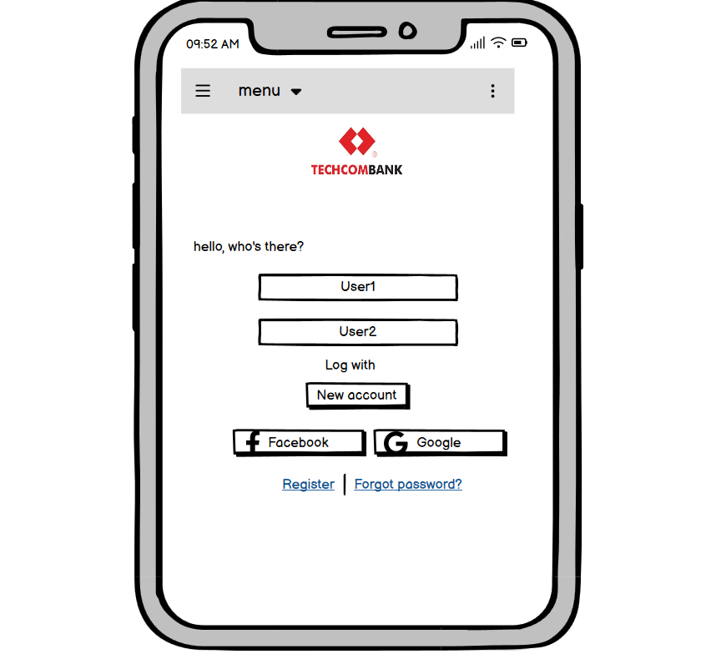
4.1.2 OTP Screen
- Used for one-time password verification.
- Field: OTP input (6-digit).
- Buttons: Confirm, Resend.
- Wireframe: 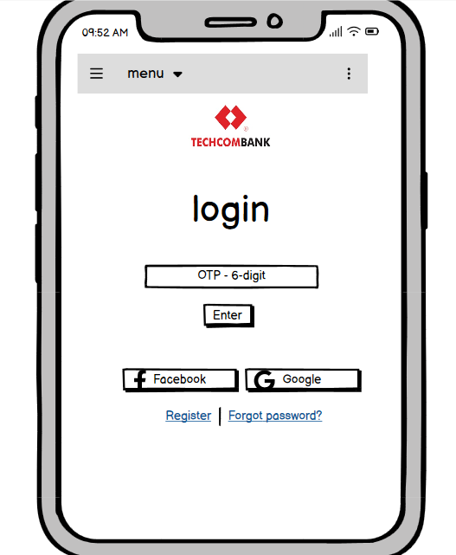
4.1.3 Switch Account Screen
- Allows users to select another saved account.
- Displays account list with account names and masked numbers.
- Wireframe: Screen1
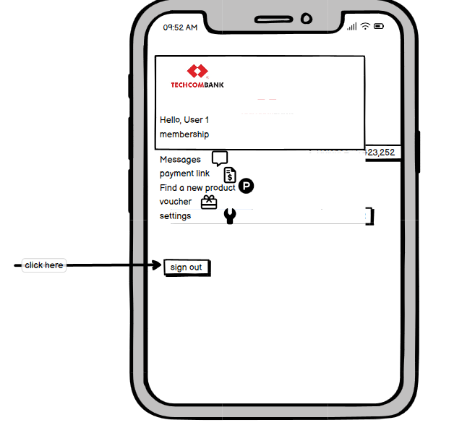
Wireframe: Screen2

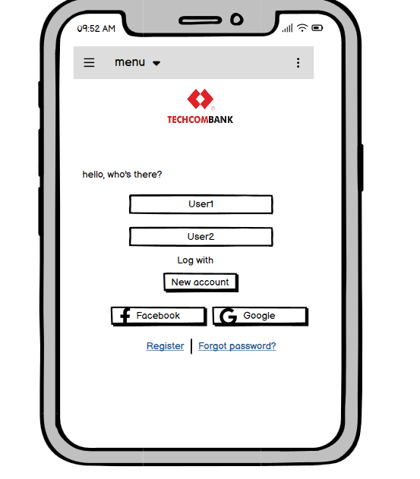
Wireframe: Screen 3 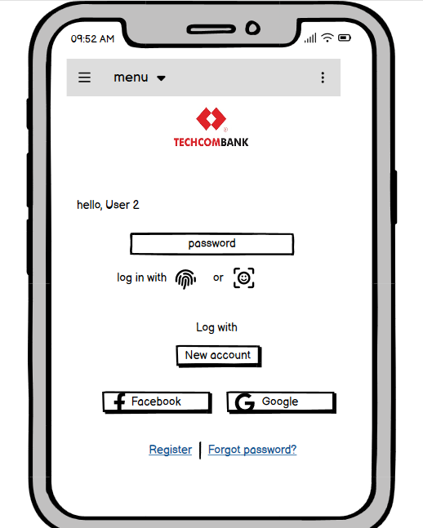
4.1.4 Dashboard Screen
- Shows the active account after login/switch.
- Contains account summary (balance, last transactions).
- Wireframe:
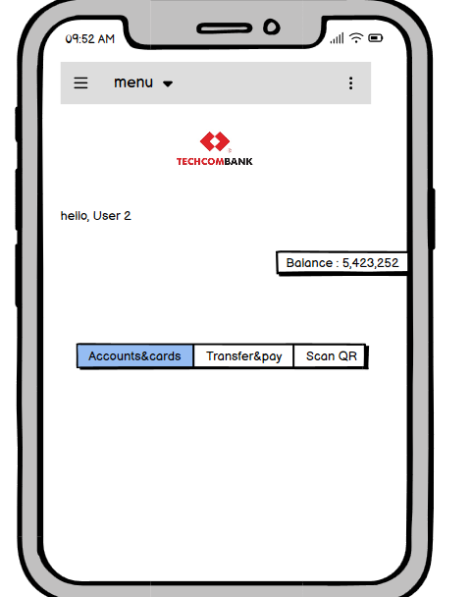

Hardware Interfaces
Smartphones with biometric hardware.

Software Interfaces
• OTP Service API.
• Authentication Backend.
• Core Banking System.

Communications Interfaces
• Secure HTTPS with TLS 1.2+.
• Data encrypted at rest and in transit.

Other Nonfunctional Requirements

Performance Requirements
• Login should complete <2 seconds.
• OTP delivered <10 seconds.

Safety Requirements
• Lockout after multiple failed attempts.
• Protect against unauthorized access.

Security Requirements
• Multi-factor authentication.
• Secure biometric handling.
• PCI DSS compliance.

Software Quality Attributes
• Reliability.
• Usability.
• Maintainability.
• Scalability.

Other Requirements
• Must support English and Vietnamese.
• Must comply with Vietnamese banking laws.
Appendix A: Glossary
• OTP = One-Time Password.
• SRS = Software Requirements Specification.
• UI = User Interface.
• UX = User Experience.
Appendix B: Analysis Models
1.Use Case Diagram
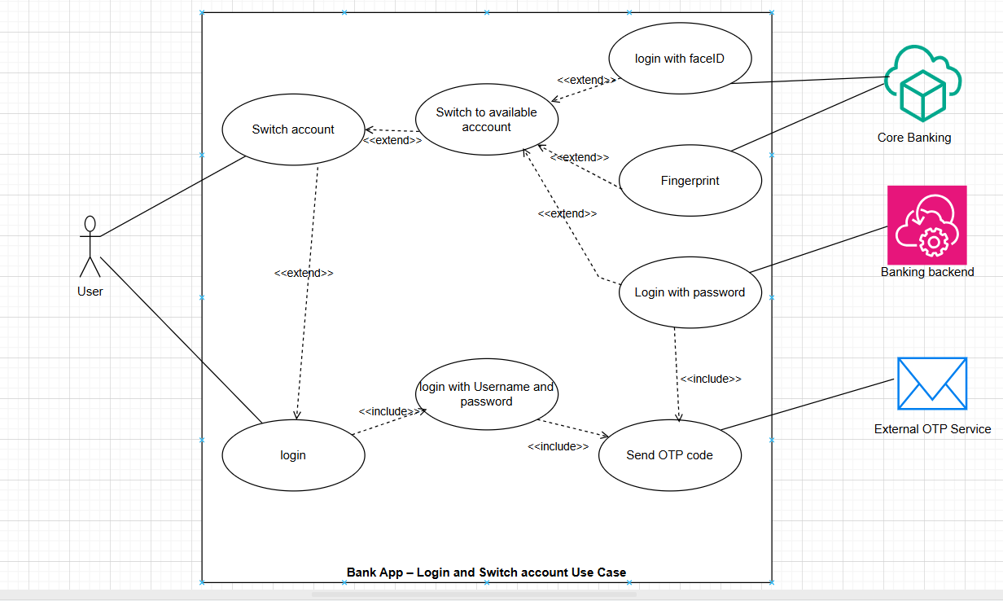
2. Sequence Diagrams
2.1 login Account

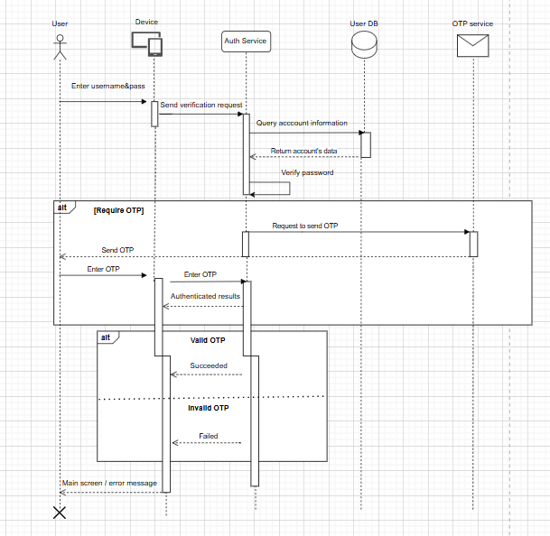

2.2 Switch Account
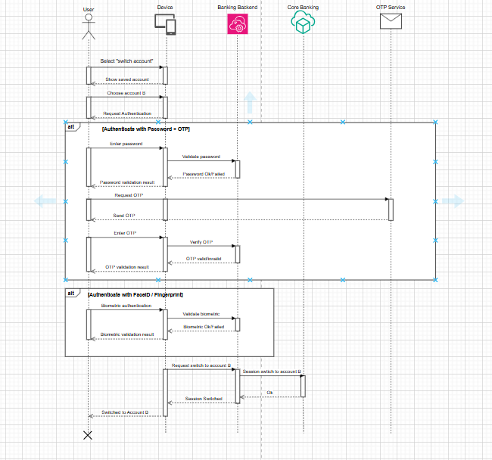
3. Wireframes
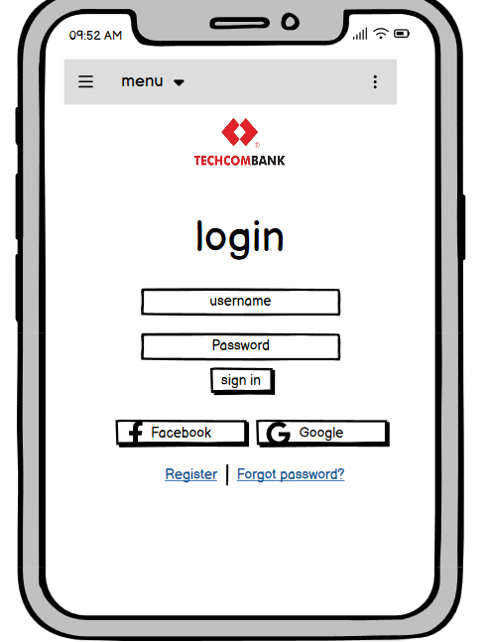
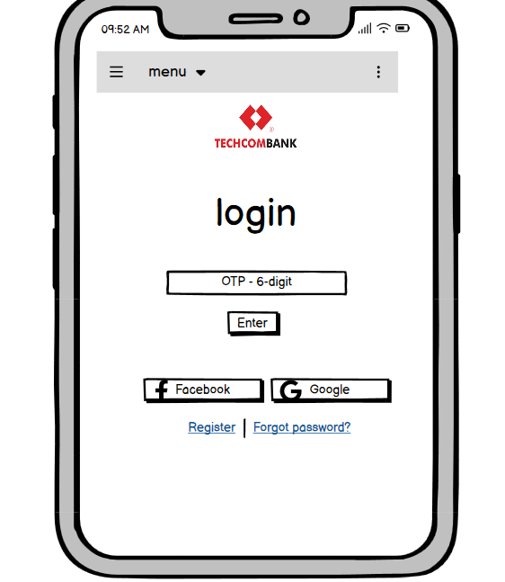
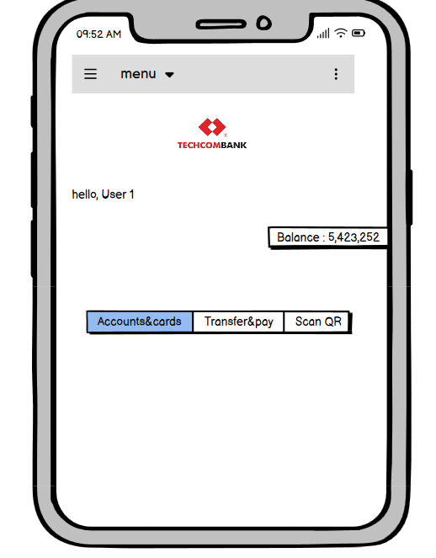
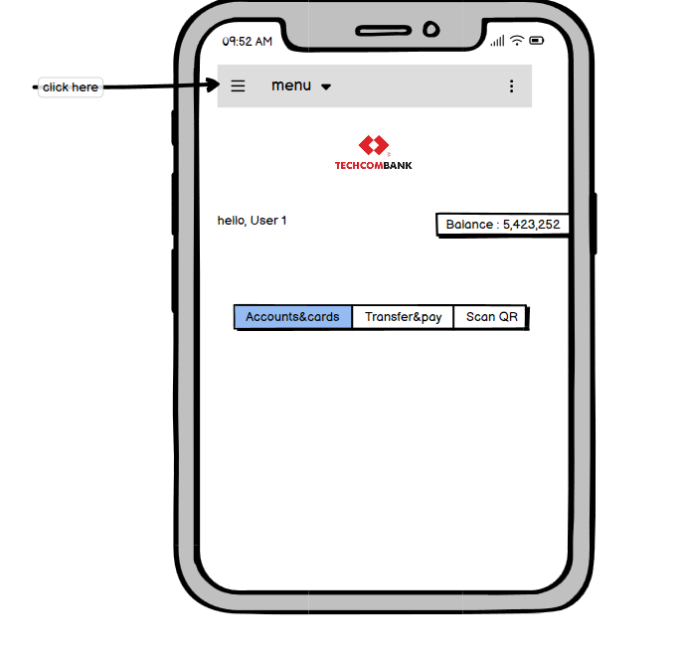
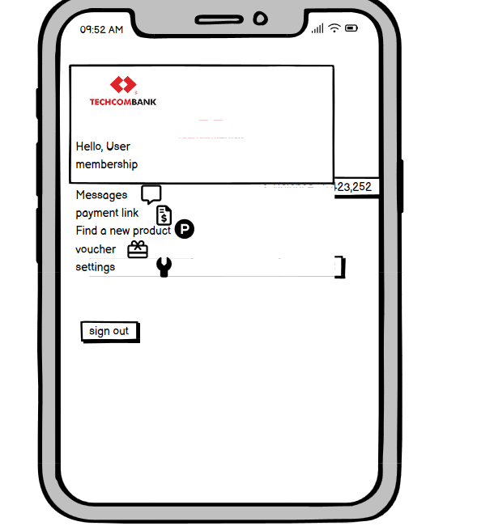

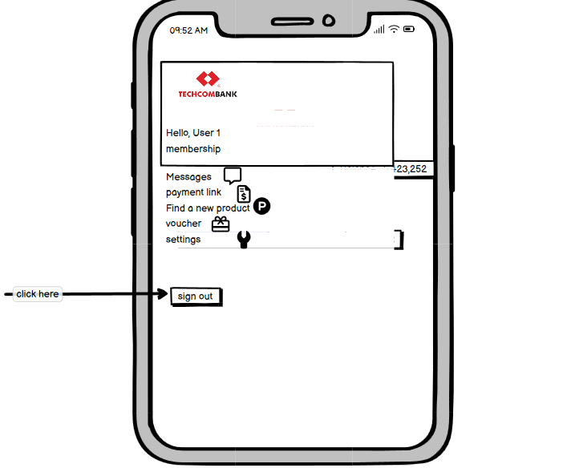
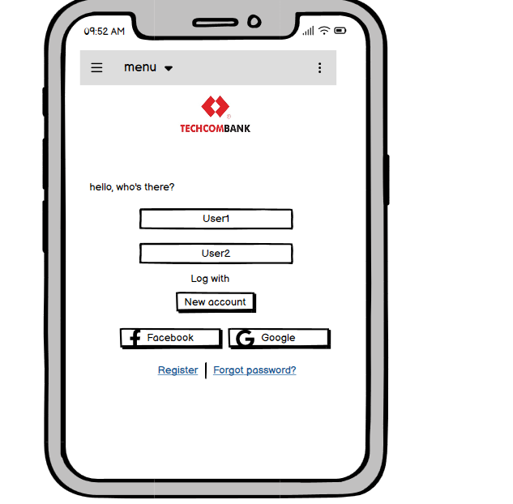
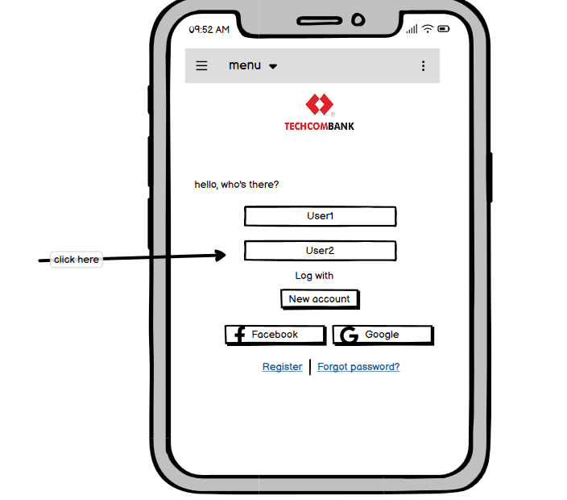
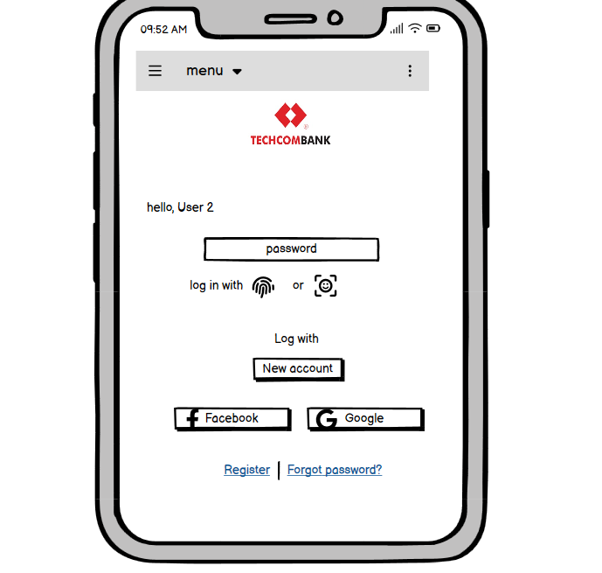
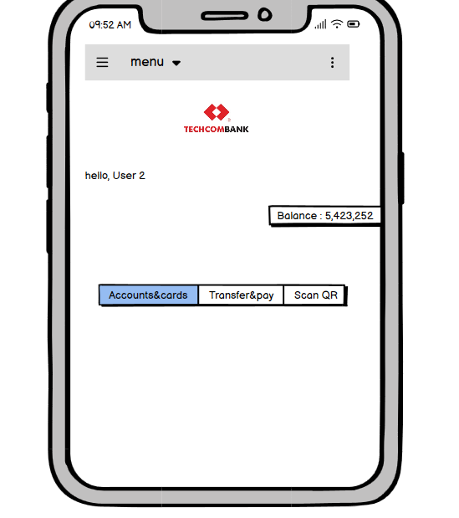
4. User Stories Table
ID | User Story | Acceptance Criteria | Priority
US-01 | As a user, I want to log in using my password and OTP so that I can securely access my bank account. | Password validated, OTP sent, access granted if correct. | High
US-02 | As a user, I want to log in using FaceID/Fingerprint so that I can access my account quickly. | Biometric validated, instant access. | High
US-03 | As a user, I want to switch between linked accounts without logging out. | Show accounts, authenticate, switch session securely. | High
US-04 | As a user, I want authentication when switching accounts. | OTP or biometric required when switching. | Medium
US-05 | As a user, I want to see which account is active. | Active account highlighted. | Medium

Appendix C: Issues List
ID | Issue | Status | Notes
IS-01 | Should the app support Smart OTP instead of SMS OTP? | Open | Need stakeholder decision.
IS-02 | Biometric support on low-end Android devices may be inconsistent. | Open | Requires further testing.
IS-03 | Switch Account flow: should OTP always be required or only once per session? | Open | Pending security team input.
IS-04 | Multi-language support (English/Vietnamese): how to handle future expansions? | Open | Out of current scope.

END

